Rectangular Area
Send Feedback

You are given a rectangle in a plane whose sides are parallel to the axes. The coordinates of one of its diagonals are provided to you. You have to print the total area of the rectangle.

The coordinates of the rectangle are provided as four integral values: x1, y1, x2, y2. It is given that x1 < x2 and y1 < y2.

Input format:
The first line of input contains an integer x1
The second line of input contains an integer y1
The third line of input contains an integer x2
The fourth line of input contains an integer y2

Constraints:
1 <= x1 <= 10
1 <= y1 <= 10
1 <= x2 <= 10
1 <= y2 <= 10
Time Limit: 1 second

Output format:
The first and only line of output contains the result.

Sample Input:
1
1
3
3

Sample Output:
4

Explanation:
The given coordinates of the diagonal are (x1,y1) = (1,1) and (x2,y2) = (3, 3).
The area of the rectangle can then easily be calculated as:
(3 – 1) * ( 3 – 1) = 2 * 2 = 4
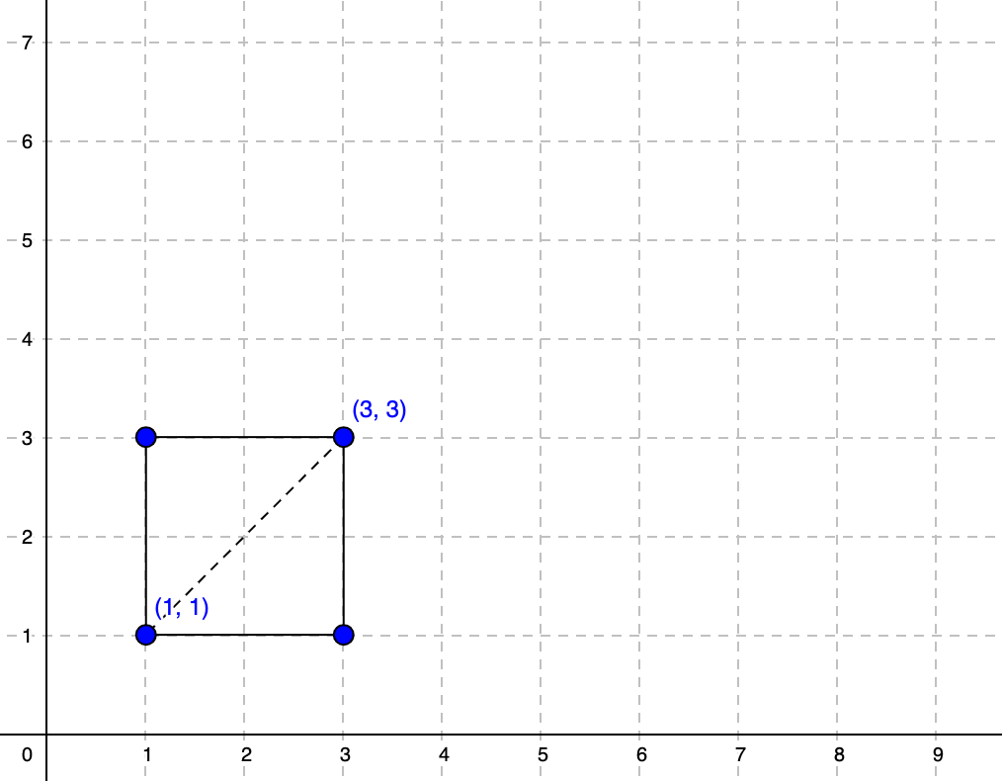

Answer:--

import java.util.Scanner;

public class Main {

public static void main(String[] args) {
Scanner sc = new Scanner(System.in);
int x1 = sc.nextInt();
int y1 = sc.nextInt();
int x2 = sc.nextInt();
int y2 = sc.nextInt();
int calcu = (x2 - x1) * (y2 - y1);
System.out.println(calcu);

}

}

